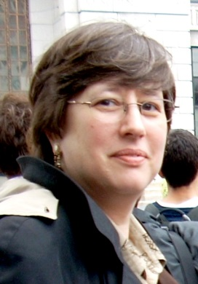 Barrie H. Gewanter

Barrie Gewanter is a professional advocate who works for human and civil rights, civil liberties and social justice. During her career, she has pursued advocacy for women’s rights, gay and lesbian and transgender rights, voting rights, students’ rights, the rights of people with disabilities, law enforcement accountability, workplace health and safety, solidarity with workers and unions, economic justice, civil rights and civil liberties.

Ms. Gewanter served as the Director of the CNY Chapter of the New York Liberties Union (NYCLU) from 1996 to 1999 and from 2003 to 2015, acting as the local spokesperson and contact point for the ACLU throughout the Central New York Region. She also served as the Executive Director of the Central New York Council on Occupational Safety and Health from 2000 to 2003.

In August 2016, Ms. Gewanter accepted a county government position as the Director of the Onondaga County/Syracuse Human Rights Commission and Administrator for the new Onondaga County Justice Center (jail) Oversight Committee. She also serves as the Title VI and ADA Coordinator for Onondaga County.

Ms. Gewanter has been involved in the enactment of a several significant local legislative and policy measures affecting the LGBT community in Syracuse, including: the implementation of same-sex domestic partner benefits at Syracuse University (1995), a law prohibiting discrimination on the basis of sexual orientation in Onondaga County (1998), a law prohibiting discrimination on the basis gender identity and expression in Syracuse (2012), an essential amendment of legislation empowering the Syracuse Citizen Review board (2012), and a law creating a new jail oversight committee in Onondaga County (2015).

Ms. Gewanter has been honored for her advocacy work by the Onondaga County/Syracuse Human Rights Commission, Peace Action of CNY and the Onondaga County/Syracuse Branch of the NAACP. Gewanter holds a B.F.A. in Theatrical Stage Management from Webster University, and has worked as a stage manager, stage carpenter and electrician in the professional theatre. Gewanter also holds a Masters Degree in Sociology from Washington University in St. Louis, and has taught college courses in Sociology and Women’s Studies at a number of colleges and universities in St. Louis, Missouri and Syracuse, New York.

Prior to focusing on her career in advocacy, she worked professionally as a theatrical technician and stage manager, and as a college instructor, mentor and tutor.

Last Revised 3/2/17

