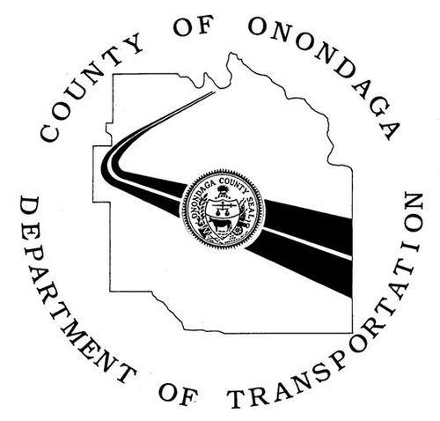
WORK ZONE ALERT

Date: December 8, 2017

Location: Intersection of John Glenn Boulevard & Farrell Road, Town of Geddes

Type of Work: Traffic Signal

Schedule: Beginning Monday, December 11, 2017 – 8:00 a.m.

Impact: Lane closure. Drivers should expect minor delays.

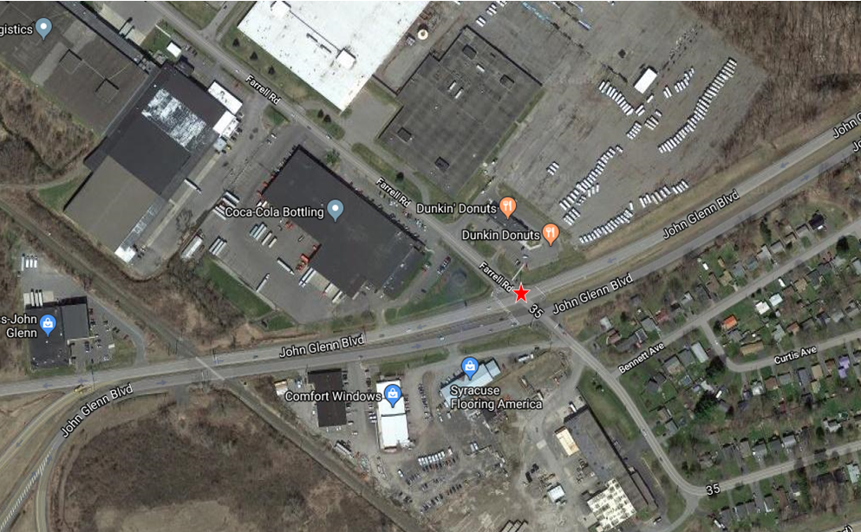

Work may be delayed due to inclement weather. As with any roadway project, the Onondaga County Department of Transportation respectfully asks the traveling public to reduce your speed within the work zone, use caution, and be mindful of roadside workers and construction vehicles. For updates on this and other Onondaga County DOT projects, visit our website, or follow us on Facebook and Twitter (@OnondagaDOT).

