The bar-coded RP-5217-PDF form is NOT intended for use as a handwritten or typewriter-entry document and will NOT be accepted with a Deed by the County Clerk as such.
Adobe Reader Version 8 or higher is required to use the RP-5217-PDF Form. Internet Explorer is the preferred browser. Please note: Chrome users have difficulty opening this Adobe form.

At this website: https://www.tax.ny.gov/pit/property/new-homebuyers/filing-rp5217.htm
- Select Download Form RP-5217-PDF below to save the form to your Downloads folder.
- Navigate to the Downloads folder on your computer or network and right-click.
- Select Open with, then choose Adobe Acrobat Reader.
DOWNLOAD FORM RP-5217-PDF

Right Click on document in your download folder. A screen will pop up and select: Always open in adobe reader.
Then go to your Adobe reader file/app.
You should see the document there.
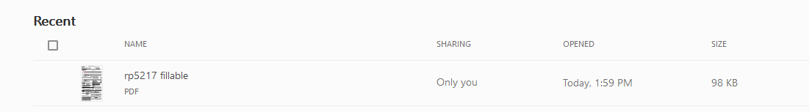
Click on the document to open it up. It will be fillable now.

